HILLY FIELDS FOOTBALL CLUB
SEASON 28: 1994-95
Beckenham Hospital Veterans Cup
P W D L F A
4 2 1 1 10 11
Friendly 27 8 6 13 82 89
TOTAL 31 10 7 14 92 100

Apps Gls Apps Gls
Irving Bartlett 2 1 Mike Lane 21 0
Adrian Bennett 22 1 John Macrea 4 0
Mark Cooper 13 0 Kevin Marchant 8 2
Alan Davies 7 0 Ray Marchant 9 0
Stuart Dyke 2 0 Steve Morton 19 7
Terry Dyke 21 0 Colin Palmer 3 0
John Felton 16 0 Richard Patterson 17 14
Barry Fitzsimmons 10 3 Steve Quinn 16 2
Keith Foster 21 3 Charlie Shoppee 1 0
Len Franklin 19 0 Mick Spicknell 2 0
Ian Graver 17 5 Ralph Stanton 1 0
Phil Hortin 3 0 Albert St Clair 10 0
Mike Jefferys 1 0 Dick Stone 5 0
Howard Jones 16 6 Mario Vaz 6 0
Mark Kellaway 6 5 Dave Wright 19 4
John Kennedy 4 2 Chris Yusuf 21 4
OG 1
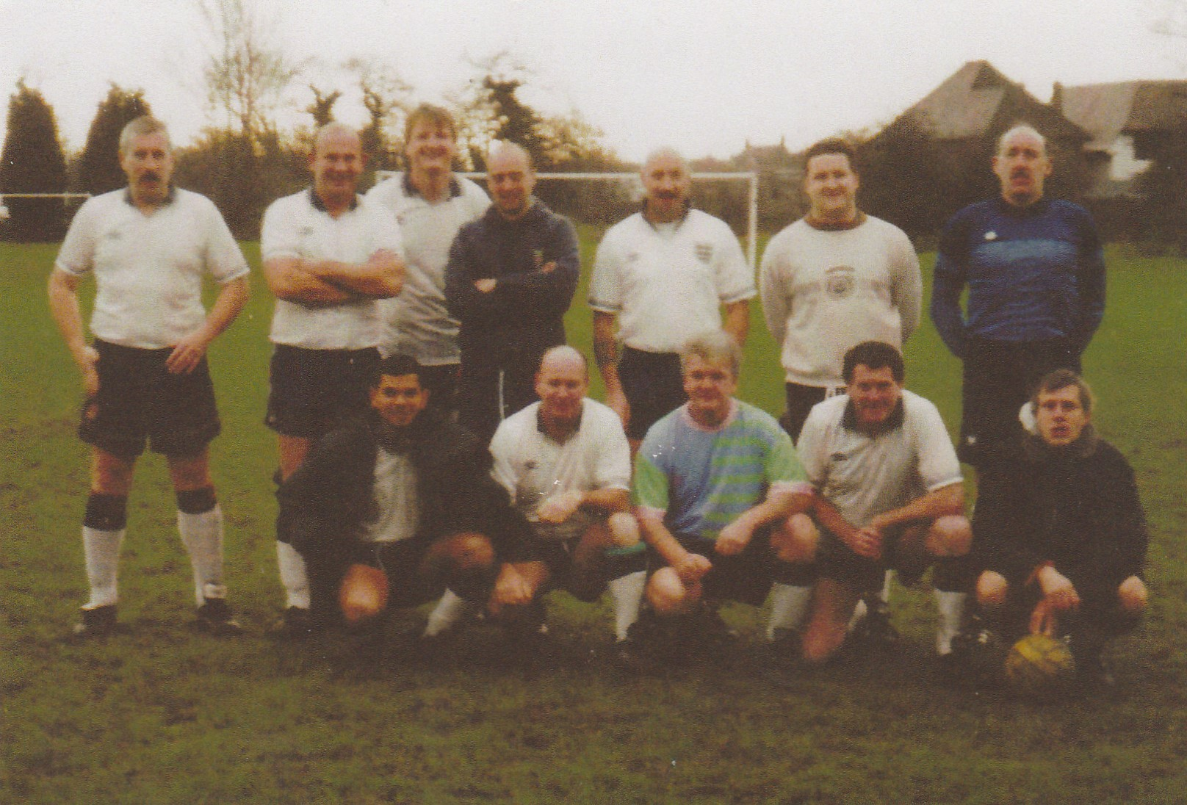
L-R Back: Terry Dyke, Adrian Bennett, Kevin Marchant, Ian Graver, Mike Lane, John Kennedy, John Macrea
L-R Front: Mario Vaz, Alan Davies, Steve Quinn, Len Franklin, John Felton

